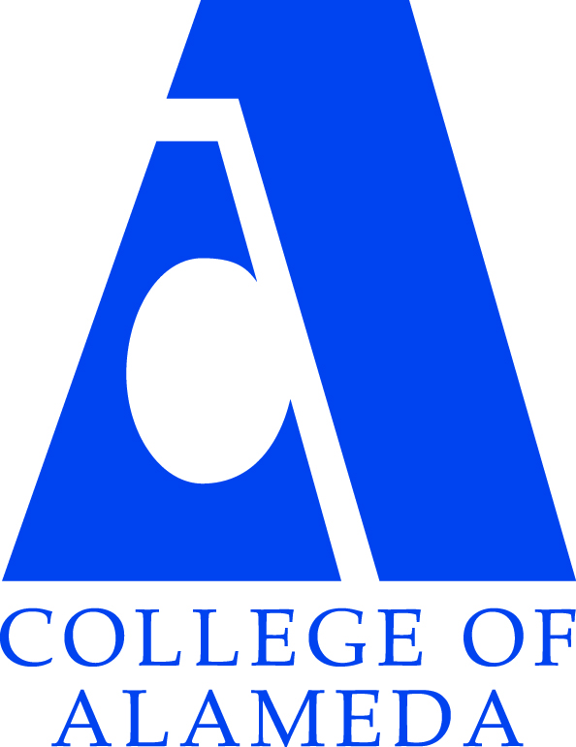College of Alameda
Goal Statements
Educational Master Plan 2015-18

# | Goals: Educational Master Plan (2016-2021)
1 | Reduce loss of students prior to start of classes
2 | Increase community and educational partnerships
3 | Advance CoA teaching and learning
4 | Increase access to college programs/coursework through collaboration with other PCCD colleges in redesigning college schedules & offerings
5 | Increase retention and persistence rates
6 | Strengthen business and industry partnerships
7 | Strengthen Data-driven / informed decision making
8 | Establish integrated planning and evaluation system
9 | Design organizational, committee, & governance structures to support student success
10 | Engage in redesign of PCCD policies and procedures, including the Budget Allocation Model

