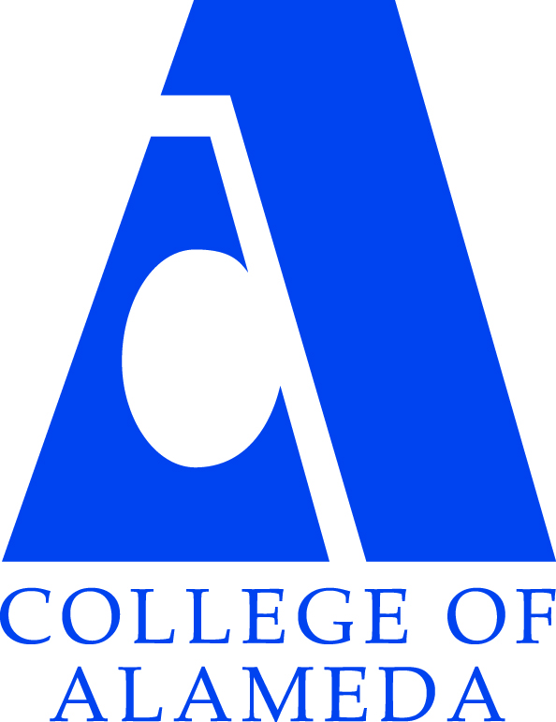GUIDED PATHWAYS 14 Elements Cross-Mapped to COA Strategic Initiatives
As of February 6, 2018 DRAFT

KEY ELEMENT | INQUIRY (1-3)  COA’s current efforts to engage campus stakeholders in actionable research and with local data; create consensus about core issues and broad solutions.
1. CROSS- FUNCTIONAL INQUIRY  College constituents (including staff, faculty across disciplines and counselors, administrators, and students) examine research and local data on student success and discuss overarching strategies to improve student success.  College engages in broad, deep and inclusive discussion and inquiry about the Guided Pathways approach, framework and evidence. | - CoA’s Participatory Governance Committees (especially the Planning, Research & Institutional Effectiveness Committee (PRIEC) and Student Success Committees) are cross-functional teams that review research and data on student success.  - All CoA programs participate in an annual program review or program update (APU) during which they look at program data and evaluate performance.  - CoA’s new Office of Research & Planning is conducting student surveys and focus groups regularly and disseminating those findings online and during Flex Days and at participatory governance meetings.  - CoA’s current participatory governance structure is undergoing review (we are at the end of our 3-year planning cycle) and changes could be made now for implementation in 2018-19 for the next 3-year cycle.  - Campus discussions about Guided Pathways are only just beginning.
2. SHARED METRICS  College is using clearly identified benchmarks and student data to track progress on key activities and student academic and employment outcomes.  Those benchmarks are shared across key initiatives. | - CoA annually develops and reviews the following benchmarks:  - Institutional Set Standards  - Institutional Effectiveness Partnership Initiative (IEPI) short and long-term goals  - Chancellor’s Office Student Success Scorecard  - Strong Workforce program and employment outcomes  - CTE Student Outcomes Survey (employment outcomes for CTE students)  - These metrics are not always shared across key initiatives.  - Many college constituents do not know about these metrics.
- INTEGRATED PLANNING  College-wide discussions are happening with all stakeholders and support/commitment has been expressed by key stakeholders to utilize the Guided Pathways framework as an overarching structure for the college’s main planning and resource allocation processes, leveraging existing initiatives and programs such as (but not limited to):  - Student Success and Support Program (SSSP)  Basic Skills Initiative/Basic Skills Student Outcomes and Transformation Program (BSI/BSSOT)  - Equity Planning (Student Equity/SE)  - Strong Workforce Program (SWF) | - CoA’s Student Success Committee developed a new BSI-SSSP-Equity Integrated Plan based on the Chancellor’s Office framework. Its goals as of January, 2018 are:  I. Increase the number of first time students who complete a transfer level English or math course within one academic year by 50% (baseline: 16-17 data).  1.a Develop and implement proactive strategies to specifically impact disproportionately affected groups. (eg. Tutoring &proactive counseling & case management counseling & embedded librarian)  II. 80% of all fulltime matriculating students will have a comprehensive SEP within their first academic year.  III. Increase the number of students who complete a certificate or degree by 25% (63 students) by June 2019.  IV. Increase the number of students who successfully complete online courses by 10% (goal: 68% completion) by June 2019.  V. Strengthen and expand community partnerships with High Schools and Community Based Organizations to support successful transitions and goal attainment of disproportionately impacted populations.  - More information can be found about CoA’s integrated planning process here.  - CoA’s Strong Workforce Program funding must result in more and better CTE programs that yield more CTE program completers who achieve wage gains in employment over time.  - CoA has a 5-year Educational Master Plan which gets operationalized each year in an annual strategic plan. This year’s plan can be accessed here.  - All of CoA’s data, research, and planning resources and documents can be found on the website of CoA’s Office of Research and Planning here.
KEY ELEMENT | DESIGN (4-8)  CoA’s current efforts to establish and use an inclusive process to make decisions about and design the key elements of Guided Pathways include:
- INCLUSIVE DECISION-MAKING STRUCTURES  College has identified key leaders that represent diverse campus constituents to steer college-wide communication, input and decisions regarding the Guided Pathways framework. Constituents have developed transparent cross-functional work-teams to provide the Guided Pathways effort with momentum and regularly provide opportunities for broad college-wide input. In addition, this plan strategically engages college governance bodies college- wide. | - CoA’s primary inclusive decision-making structures are our participatory governance committees. This include representatives from all of CoA’s primary stakeholder groups: students, faculty, staff, and administrators.  - To begin work on Guided Pathways, the Academic Senate and President Karas have convened a CoA Guided Pathways steering group that is expressly comprised of representatives from both student services and instruction. This Committee will communicate its work to the larger CoA community and present its recommendations to participatory governance committees as well as the Academic Senate.
- INTERSEGMENTAL ALIGNMENT  (Clarify the Path)  College engages in systematic coordination with K-12, four-year institutions and industry partners to inform program requirements. | CoA aligns with K12, 4-year, and industry partners as follows:  - CoA offers dual enrollment courses at area high schools and supports those students in transitioning to CoA  - CoA hosts an early college high school (Alameda Science and Technology Institute (ASTI) on campus  - CoA Outreach staff visit area high schools and other community-based organizations to identify and assist potential students – especially via “Mobile CoA” which allows for off-site assessment, orientation, and enrollment.  - CoA Adult Education-funded Transitions Liaison and Associate Dean coordinate and align assessment, enrollment, and program development with a variety of community partners: adult schools, re-entry programs, prisons, court, community, and continuation high schools, community-based organizations and faith-based organizations to assist students in finding and enrolling in CoA  - All of CoA’s CTE programs have or participate in regional industry advisory boards where they work with employers to evaluate and update curriculum  - CoA’s Articulation Officer (Vinh Phan) works with 4-year institutions (CSU’s and UC’s and others) to ensure our students can articulate effectively  - CoA’s Transfer Center (Vivian Virkkila) works with 4-year institutions to connect CoA students to transfer opportunities and to facilitate the transfer process
- GUIDED MAJOR AND CAREER EXPLORATION OPPORTUNITIES  (Help Students Choose and Enter a Pathway)  College has structures in place to scale major and career exploration early on in a student’s college experience. | - In 2017, CoA faculty designed a First Year Experience (FYE) program which included STEM and non-STEM pathways for FYE cohorted students. It has yet to be implemented.  - CoA offers Counseling classes that include:  - Counseling 24: College Success  - Counseling 57: Career and Life Planning  - Counseling 200: Orientation to College  - Counseling 207: Career Exploration  - CoA offers general and occupational Cooperative Work Experience classes (COOP Ed.) but only on a limited basis right now
- IMPROVED BASIC SKILLS  (Help Students Choose and Enter a Pathway; Ensure Students are Learning)  College is implementing evidence-based practices to increase access and success in college and/or transfer- level math and English, including, but not limited to:  - The use of high school performance for placement (i.e. cumulative GPA, course grades, non- cognitive measures) for placement  Co-requisite remediation or shortening of developmental sequence  - Curricular innovations including creation of math pathways to align with students’ field of study. | - In 2016, CoA received a 3-year grant from the Chancellor’s Office Basic Skills Student Outcomes Transformation (BSSOT) initiative. This is funding faculty time to develop and implement the following:  - Implement an English Writing Assessment  - Create and offer a one-week “math jam” course (noncredit) at the start of each semester allowing students to prep for their initial math assessment  - Create a new “co-requisite” course (Math 213) and offer it concurrently with Math 13. Revise math assessment and placement procedures to direct non-STEM majors assessed at the current level of MATH 201 or 250 to instead enroll in MATH 13 and the new co-requisite MATH 213.  - Create a new “co-requisite” course (English 208) – a writing workshop – and offer it concurrently with English 201B-A. Pilot and possibly scale this practice to improve student outcomes.  - Create a contextualized math class for CoA CTE programs  - Train tutors and assign them, and counselors, to support students in English 201B and 201A. Deliver tutoring to students in accelerated basic skills courses.  - Develop non-credit basic skills courses and develop rubric for assessing students to identify students most appropriate for such courses.  - Develop an accelerated pre-statistics course for non-STEM majors (Math 206 and Math 13). Evaluate and scale if effective.  - Develop an accelerated math course (combining elementary algebra and intermediate algebra) intended for STEM majors.  - Use high school grades for placement: in spring 2016, CoA joined sister colleges in accepting student high school transcripts rather than assessment test scores to place students into math and English
- CLEAR PROGRAM REQUIREMENTS  (Clarify the Path)  College is clarifying course sequences for programs of study (including key milestones) and creating predictable schedules so that students can know what they need to take, plan course schedules over an extended period of time, and easily see how close they are to completion. College offers courses to meet student demand.  In order to meet these objectives, college is engaging in backwards design with desired core competencies and/or student outcomes in mind (including time-to-goal completion and enhanced access to relevant transfer and career outcomes). | - Starting in 2018, CoA is implementing a new block schedule
KEY ELEMENTS | IMPLEMENTATION (9-14)  CoA’s current efforts to adapt and implement the key components of Guided Pathways to meet student needs at scale include:
- PROACTIVE AND INTEGRATED STUDENT SUPPORTS  (Help Students Stay on the Path)  College provides academic and non- academic support services in a way that is proactive and aligned with instruction, so that all students are explicitly engaged in these services. | - CoA offers the following support services:  - Orientation, Assessment, Education Planning services (SSSP)  - Extended Opportunity Program and Services (EOPS) encourages enrollment, retention, and transition services to students disadvantaged by language, social, economic and educational circumstances (students must be deemed eligible)  - CoA’s NextUp program is designed to promote the success of current and former foster youth enrolled at CoA  - CoA’s Mathematics Engineering Science Achievement (MESA) program (at Atlantic) is a peer and professional support community to increase access and opportunities of success in STEM-related fields to students who are the first in their family to graduate college, and come from a low-income and historically underrepresented background.  - Programs and Services for Students with Disabilities (DSPS)  - CoA’s New D.R.E.A.M. program offers support services to formerly incarcerated students
- INTEGRATED TECHNOLOGY INFRASTRUCTURE  (Help Students Choose and Enter a Pathway; Help Students Stay on the Path)  College has the technology infrastructure to provide tools for students as well as instructional, counseling, and student support faculty and staff to support planning, tracking, and outcomes for Guided Pathways including:  - Link student demand to scheduling  - Ability for students to monitor schedule and progress (e.g., Degree Audit)  System for counselors and faculty to monitor students’ progress (e.g., Starfish, early alert system, etc.)  - Data on career and employment opportunities including salary and requirements (e.g., SalarySurfer, other) | - CoA’s piloting Starfish Spring 2018  - CoA initiated a pilot of the District’s Early Alert system Spring 2017.  - Data on career and employment opportunities can be found, to some extent, on each of CoA’s CTE program websites, as well as on the District CTE website.
- STRATEGIC PROFESSIONAL DEVELOPMENT  (Help Students Stay on the Path; Ensure Students are Learning)  Professional Development (PD) is strategically, frequently, and consistently offered for staff, faculty and administrators and aligned with the college’s strategic goals, needs and priorities identified in integrated plans, program review, and other intentional processes. | - CoA’s Academic Senate has a Professional Development Committee which oversees professional development for faculty, including organizing college “flex” days  - CoA’s Classified Senate also offers workshops and professional development opportunities to CoA staff
- ALIGNED LEARNING OUTCOMES  (Ensure Students are Learning)  Learning outcomes are aligned with the requirements targeted by each program and across all levels (i.e., course, program, institutional) to ensure students’ success in subsequent educational, employment, and career goals. | - CoA instructional programs have student learning outcomes identified and posted in Curricunet Meta – these get reviewed each year during the program review and annual program update (APU) process.  - CoA is currently working with the District (Academic Affairs and IT) to integrate course, program and institutional learning outcomes with program and college planning and resource allocations via a new, online system for program review and planning. Due to be piloted in Fall 2018.
- ASSESSING AND DOCUMENTING LEARNING  (Ensure Students are Learning)  The college tracks attainment of learning outcomes and that information is easily accessible to students and faculty. Consistent and ongoing assessment of learning is taking place to assess whether students are mastering learning outcomes and building skills across each program and using results of learning outcomes assessment to improve the effectiveness of instruction in their programs. | - CoA instructional programs have student learning outcomes (SLO’s) identified and posted in Curricunet Meta. This is accessible to faculty but not students.  - 3 faculty (Student Learning Outcomes Coordinators or SLOACs) are compensated for helping other faculty develop, measure, and track student learning outcomes in their courses.  - Course level SLO’s get reviewed each year during the program review and annual program update (APU) process. These are currently NOT measured at the student level at the Peralta Colleges. Other colleges are beginning to measure and track SLO’s at a student level, allowing the outcomes to be disaggregated by ethnicity, gender, age and other demographics to determine if any group is disproportionately impacted.
14. APPLIED LEARNING OPPORTUNITIES  (Ensure Students are Learning)  Students have ample opportunity for applied/contextualized learning and practice. Opportunities have been coordinated strategically within and/or amongst programs. | - Some of CoA’s Science programs take students on field trips  - CoA is building a new FabLab with grant funds which include resources for faculty to develop “hands on” learning modules they can incorporate in their existing or new curriculum using tools in the FabLab.  - Some of CoA’s CTE programs offer or require “occupational” coop ed – work experience where they apply what they have learned in class.

