College of Alameda
Guided Pathways Inquiry Lunch #1
April 16, 2018
Minutes: transcribed by Karen Engel, interim Dean of Research & Planning

Introductions. Attendee list is here.
Agenda Overview. Dean Engel and Rachel Antrobus presented their proposed agenda for the meeting. See slide deck. It was accepted.
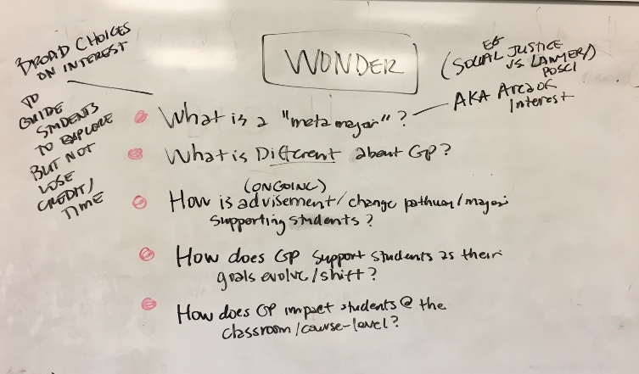
Know and Wonder: The group discussed what they feel they know about Guided Pathways as well as questions they still have. See whiteboard below:
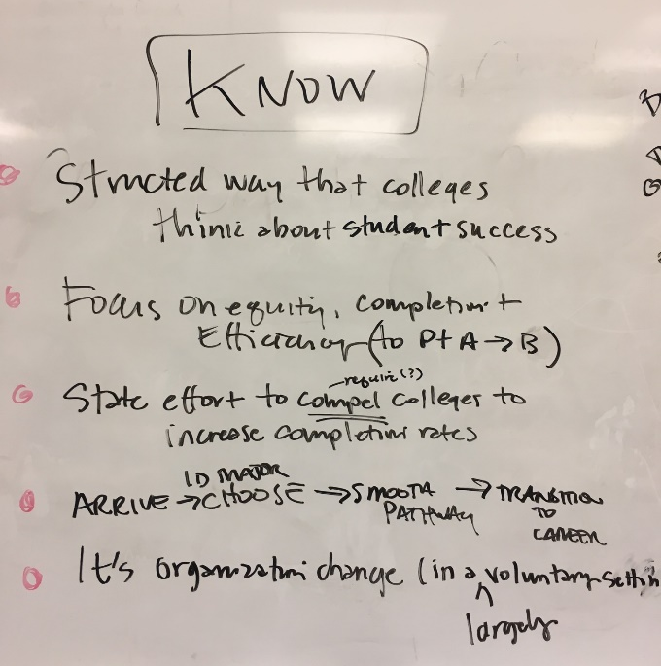

Short presentation: Dean Engel presented some of the key performance indicators (KPIs) the state generated for COA and raised the question: what is the problem we are trying to solve? Rachel Antrobus gave a more nuanced description of what the state Guided Pathways framework is, along with examples of what colleges are working on in each of the four pillars.
Discussion:
- Are the Key Performance Indicators COA enrollments only or do they include outcomes and units earned by COA students across the District? It would help to have the data disaggregated to look at the effects of swirl on our students’ abilities to complete and transfer.
- Can we also look at data that shows what happened to our 665 first-time students (2015-16)? Did they go to another college? Did they meet their goals somewhere, if not here? We need to personify the KPIs. What happened to all the students (52%) that didn’t persist from fall to spring?
- What is the role of faculty in creating a lot more stackable, short-term certificates, and then encouraging their students to complete many smaller milestones on their way to completing the bigger ones?
- What about students who come here for reasons other than complete a degree, certificate or transfer? Shouldn’t we peel them out and consider them separately?
- Over the years, COA faculty and staff have launched many innovative programs and practices to deal with these issues. What happened to those efforts? Shouldn’t we understand what happened to them first, before we launch another one? Let’s look at why they succeeded as well as why they failed.
- How shall we conduct our inquiry process? Other colleges have created book clubs and divided up and share their responses to books like the one that launched much of the Guided Pathways thinking like Redesigning America’s Community Colleges: A Clearer Path to Student Success, by Thomas Bailey, Shanna Smith Jaggars, and Davis Jenkins. We could also review the “14 elements” of the GP framework as defined by the Chancellor’s Office and what successful college practices look like in each of these elements.
- Need for visualizations! Can we get a visualization of what this looks like? What does it look like NOW for students, and what would it look like if we’re successful? What are the changes our students would experience? Can we employ a graphic recorder to help with this? Can we see a visual of what this looks like?
- How will we capture the student voice? Don’t we need to start with that?
- How will we capture PT faculty input?
- How can we get input from students who came and left without completing or transferring?
- How can we communicate effectively and broadly with students and FAS? Social Media? A physical room or place (control center) for the project? We have a website….
- Can we get a diagram of what other colleges are implementing? A big picture that gets broken down? People need visual explanation. It’s still not clear.
- Can we apply Design Thinking? Start with the end in mind? Look at it all from the students’ experience?
- Faculty may be wondering, how is it going to impact me? How am I going to do things differently? Let’s thinking about how we think through that and help faculty think about that.

For Next Time:
- Robert Brem and Maurice Jones offered to help compile a list of prior initiatives and efforts and what happened to them at COA
- Future meetings will be structured in a way so that every voice can be heard (break out groups; note cards submitted, etc)
- Aja, Cat, and Cleamaus (and ASCOA) will give some thought to how we can capture student input in this process – especially during this inquiry phase.
- Dean Engel will share results of December student focus group as well as results from the Interact Survey of students who enrolled but did not return.

