Click on the link below to access the Title 5, Division 6 (California Community Colleges), Chapter 6 for the latest California Codes and Community Colleges Regulations:

https://govt.westlaw.com/calregs/Browse/Home/California/CaliforniaCodeofRegulations?transitionType=Default&contextData=(sc.Default)&bhcp=1

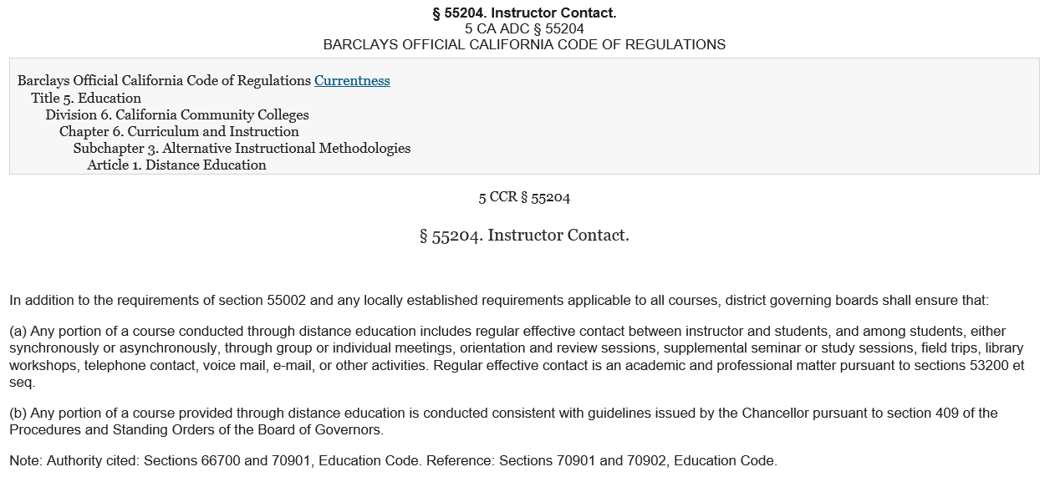

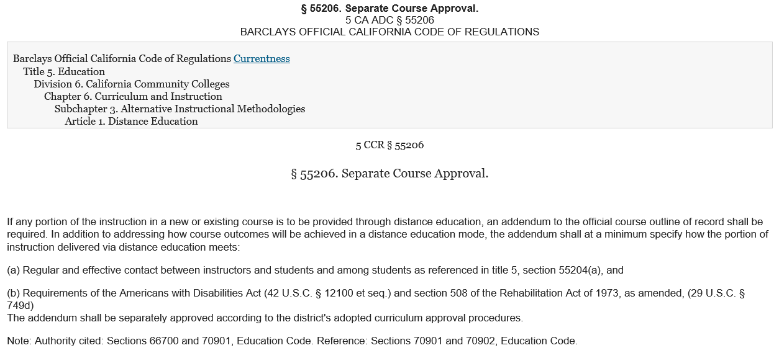

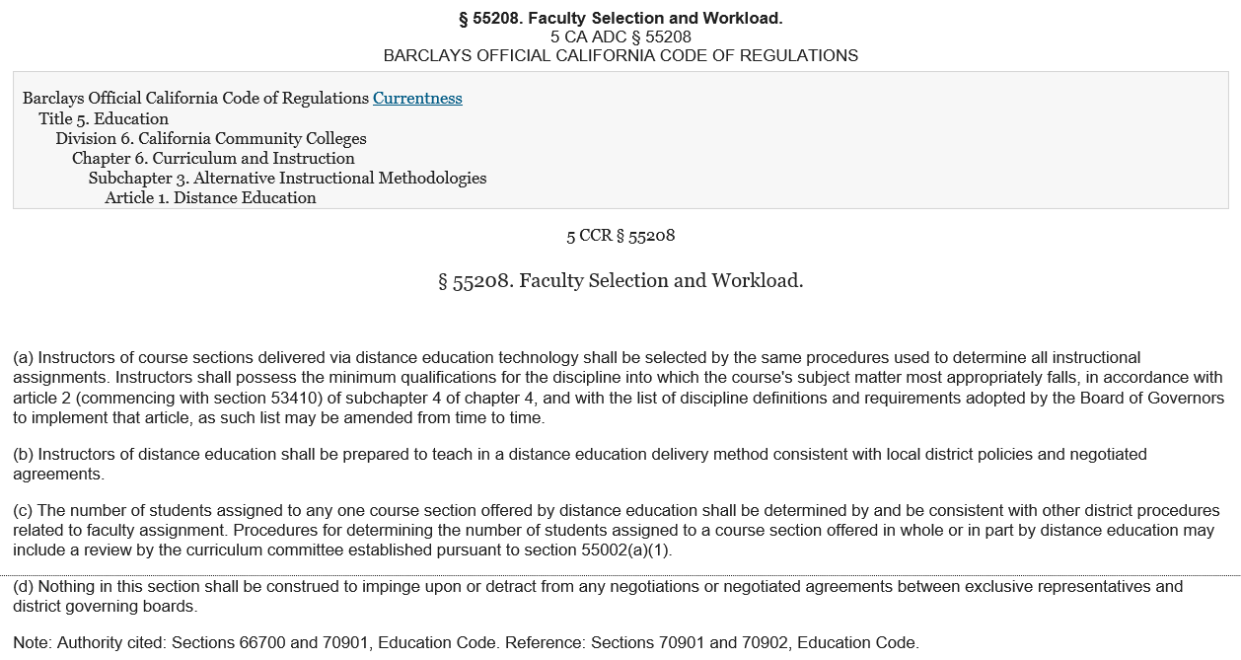

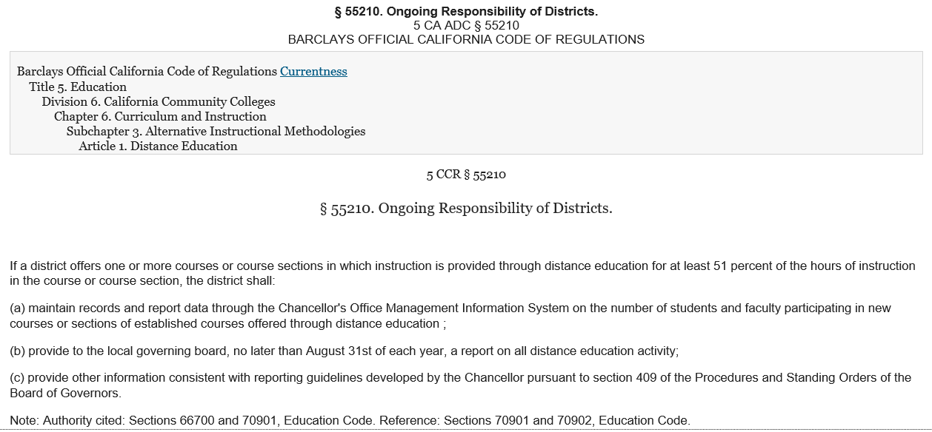

§ 55002. Standards and Criteria for Courses.
5 CA ADC § 55002BARCLAYS OFFICIAL CALIFORNIA CODE OF REGULATIONS
Barclays Official California Code of Regulations Currentness
Title 5. Education
Division 6. California Community Colleges
Chapter 6. Curriculum and Instruction
Subchapter 1. Programs, Courses and Classes
Article 1. Program, Course and Class Classification and Standards
5 CCR § 55002
§ 55002. Standards and Criteria for Courses.

(a) Degree-Applicable Credit Course. A degree-applicable credit course is a course which has been designated as appropriate to the associate degree in accordance with the requirements of section 55062, and which has been recommended by the college and/or district curriculum committee and approved by the district governing board as a collegiate course meeting the needs of the students.

(1) Curriculum Committee. The college and/or district curriculum committee recommending the course shall be established by the mutual agreement of the college and/or district administration and the academic senate. The committee shall be either a committee of the academic senate or a committee that includes faculty and is otherwise comprised in a way that is mutually agreeable to the college and/or district administration and the academic senate.

(2) Standards for Approval. The college and/or district curriculum committee shall recommend approval of the course for associate degree credit if it meets the following standards:

(A) Grading Policy. The course provides for measurement of student performance in terms of the stated course objectives and culminates in a formal, permanently recorded grade based upon uniform standards in accordance with section 55023. The grade is based on demonstrated proficiency in subject matter and the ability to demonstrate that proficiency, at least in part, by means of essays, or, in courses where the curriculum committee deems them to be appropriate, by problem solving exercises or skills demonstrations by students.

(B) Units. The course grants units of credit in a manner consistent with the provisions of section 55002.5. The course outline of record shall record the total number of hours in each instructional category specified in governing board policy, the total number of expected outside-of-class hours, and the total student learning hours used to calculate the award of credit.

(C) Intensity. The course treats subject matter with a scope and intensity that requires students to study independently outside-of-class time.

(D) Prerequisites and Corequisites. When the college and/or district curriculum committee determines, based on a review of the course outline of record, that a student would be highly unlikely to receive a satisfactory grade unless the student has knowledge or skills not taught in the course, then the course shall require prerequisites or corequisites that are established, reviewed, and applied in accordance with the requirements of this article.

(E) Basic Skills Requirements. If success in the course is dependent upon communication or computation skills, then the course shall require, consistent with the provisions of this article, as prerequisites or corequisites eligibility for enrollment in associate degree credit courses in English and/or mathematics, respectively.

(F) Difficulty. The course work calls for critical thinking and the understanding and application of concepts determined by the curriculum committee to be at college level.

(G) Level. The course requires learning skills and a vocabulary that the curriculum committee deems appropriate for a college course.

(3) Course Outline of Record. The course is described in a course outline of record that shall be maintained in the official college files and made available to each instructor. The course outline of record shall specify the unit value, the expected number of contact hours, outside-of-class hours, and total student learning hours for the course as a whole; the prerequisites, corequisites, or advisories on recommended preparation (if any) for the course; the catalog description, objectives, and content in terms of a specific body of knowledge. The course outline of record shall also specify types or provide examples of required reading and writing assignments, other outside-of-class assignments, instructional methodology, and methods of evaluation.

(4) Conduct of Course. Each section of the course is to be taught by a qualified instructor in accordance with a set of objectives and with other specifications defined in the course outline of record.

(5) Repetition. Repeated enrollment is allowed only in accordance with the provisions of article 4 of subchapter 1 of chapter 6 (commencing with section 54040), and section 58161.

(b) Nondegree-Applicable Credit Course. A credit course designated by the governing board as not applicable to the associate degree is a course which, at a minimum, is recommended by the college and/or district curriculum committee (the committee described and established under subdivision (a)(1) of this section) and is approved by the district governing board.

(1) Types of Courses. Nondegree-applicable credit courses are:

(A) nondegree-applicable basic skills courses as defined in subdivision (u) of section 55000;

(B) courses designed to enable students to succeed in degree-applicable credit courses (including, but not limited to, college orientation and guidance courses, and discipline-specific preparatory courses such as biology, history, or electronics) that integrate basic skills instruction throughout and assign grades partly upon the demonstrated mastery of those skills;

(C) precollegiate career technical preparation courses designed to provide foundation skills for students preparing for entry into degree-applicable credit career technical courses or programs;

(D) essential career technical instruction for which meeting the standards of subdivision (a) is neither necessary nor required.

(2) Standards for Approval. The college and/or district curriculum committee shall recommend approval of the course on the basis of the standards which follow.

(A) Grading Policy. The course provides for measurement of student performance in terms of the stated course objectives and culminates in a formal, permanently recorded grade based upon uniform standards in accordance with section 55023. The grade is based on demonstrated proficiency in the subject matter and the ability to demonstrate that proficiency, at least in part, by means of written expression that may include essays, or, in courses where the curriculum committee deems them to be appropriate, by problem solving exercises or skills demonstrations by students.

(B) Units. The course grants units of credit in a manner consistent with the provisions of section 55002.5. The course outline of record shall record the total number of hours in each instructional category specified in governing board policy, the total number of expected outside-of-class hours, and the total student learning hours used to calculate the award of credit.

(C) Intensity. The course provides instruction in critical thinking and generally treats subject matter with a scope and intensity that prepares students to study independently outside-of-class time and includes reading and writing assignments and homework. In particular, the assignments will be sufficiently rigorous that students successfully completing each such course, or sequence of required courses, will have acquired the skills necessary to successfully complete degree-applicable work.

(D) Prerequisites and corequisites. When the college and/or district curriculum committee deems appropriate, the course may require prerequisites or corequisites for the course that are established, reviewed, and applied in accordance with this article.

(3) Course Outline of Record. The course is described in a course outline of record that shall be maintained in the official college files and made available to each instructor. The course outline of record shall specify the unit value, the expected number of contact hours, outside-of-class hours, and total student learning hours for the course as a whole; the prerequisites, corequisites, or advisories on recommended preparation (if any) for the course; the catalog description, objectives, and content in terms of a specific body of knowledge. The course outline of record shall also specify types or provide examples of required reading and writing assignments, other outside-of-class assignments, instructional methodology, and methods of evaluation.

(4) Conduct of Course. All sections of the course are to be taught by a qualified instructor in accordance with a set of objectives and with other specifications defined in the course outline of record.

(5) Repetition. Repeated enrollment is allowed only in accordance with the provisions of article 4 of subchapter 1 of chapter 6 (commencing with section 54040), and section 58161.

(c) Noncredit Course. A noncredit course is a course which, at a minimum, is recommended by the college and/or district curriculum committee (the committee described and established under subdivision (a)(1) of this section) and approved by the district governing board as a course meeting the needs of enrolled students.

(1) Standards for Approval. The college and/or district curriculum committee shall recommend approval of the course if the course treats subject matter and uses resource materials, teaching methods, and standards of attendance and achievement that the committee deems appropriate for the enrolled students. In order to be eligible for state apportionment, such courses must be approved by the Chancellor pursuant to article 2 (commencing with section 55150) of subchapter 2 of this chapter and satisfy the requirements of section 58160 and other applicable provisions of chapter 9 (commencing with section 58000) of this division.

(2) Course Outline of Record. The course is described in a course outline of record that shall be maintained in the official college files and made available to each instructor. The course outline of record shall specify the number of contact hours normally required for a student to complete the course, the catalog description, the objectives, contents in terms of a specific body of knowledge, instructional methodology, examples of assignments and/or activities, and methods of evaluation.

(3) Conduct of Course. All sections of the course are to be taught by a qualified instructor in accordance with the set of objectives and other specifications defined in the course outline of record.

(4) Repetition. Repeated enrollment is allowed only in accordance with provisions of article 4 of subchapter 1 of chapter 6 (commencing with section 54040), and section 58161.

(d) Community Services Offering. A community services offering must meet the following minimum requirements:

(1) is approved by the district governing board;

(2) is designed for the physical, mental, moral, economic, or civic development of persons enrolled therein;

(3) provides subject matter content, resource materials, and teaching methods which the district governing board deems appropriate for the enrolled students;

(4) is conducted in accordance with a predetermined strategy or plan;

(5) is open to all members of the community willing to pay fees to cover the cost of the offering; and

(6) may not be claimed for apportionment purposes.
Note: Authority cited: Sections 66700 and 70901, Education Code. Reference: Section 70901, Education Code.

§ 55002.5. Credit Hour Definition.
5 CA ADC § 55002.5BARCLAYS OFFICIAL CALIFORNIA CODE OF REGULATIONS
Barclays Official California Code of Regulations Currentness
Title 5. Education
Division 6. California Community Colleges
Chapter 6. Curriculum and Instruction
Subchapter 1. Programs, Courses and Classes
Article 1. Program, Course and Class Classification and Standards
5 CCR § 55002.5
§ 55002.5. Credit Hour Definition.
(a) One credit hour of community college work (one unit of credit) shall require a minimum of 48 semester hours of total student work or 33 quarter hours of total student work, which may include inside and/or outside-of-class hours.

(b) A course requiring 96 hours or more of total student work at colleges operating on the semester system or 66 hours or more of total student work at colleges operating on the quarter system shall provide at least 2 units of credit.

(c) Cooperative work experience courses defined in section 55252 shall adhere to the formula for credit hour calculations identified in section 55256.5.

(d) For programs designated by the governing board as clock hour programs, units of credit shall be awarded in a manner consistent with the provisions of 34 Code of Federal Regulations part 600.2.

(e) Credit hours for all courses may be awarded in increments of one unit or less.

(f) The governing board of each community college district shall establish policy, consistent with the provisions of this section, defining the standards for credit hour calculations. District policy shall specify the credit hour calculation method for all academic activities, expected ratios of in-class to outside-of-class hours for each type of academic activity, standards for incremental award of credit, standard term length, calculation methods for short term and extended term courses, and provisions for monitoring compliance with state and federal regulations related to credit hour calculations.

§ 55003. Policies for Prerequisites, Corequisites and Advisories on Recommended Preparation.
5 CA ADC § 55003BARCLAYS OFFICIAL CALIFORNIA CODE OF REGULATIONS
Barclays Official California Code of Regulations Currentness
Title 5. Education
Division 6. California Community Colleges
Chapter 6. Curriculum and Instruction
Subchapter 1. Programs, Courses and Classes
Article 1. Program, Course and Class Classification and Standards
5 CCR § 55003
§ 55003. Policies for Prerequisites, Corequisites and Advisories on Recommended Preparation.
(a) The governing board of a community college district may establish prerequisites, corequisites, and advisories on recommended preparation, but must do so in accordance with the provisions of this article. Nothing in this subchapter shall be construed to require a district to establish prerequisites, corequisites, or advisories on recommended preparation; provided however, that a prerequisite or corequisite shall be required if the course is to be offered for associate degree credit and the curriculum committee finds that the prerequisite or corequisite is necessary pursuant to sections 55002(a)(2)(D) or 55002(a)(2)(E). Unless otherwise specified in this section, the level of scrutiny required to establish prerequisites, corequisites, and advisories on recommended preparation shall be based on content review as defined in subdivision (c) of section 55000 or content review with statistical validation as defined in subdivision (f) of this section. Determinations about prerequisites and corequisites shall be made on a course-by-course or program-by-program basis.

(b) A district governing board choosing to establish prerequisites, corequisites, or advisories on recommended preparation shall, in accordance with the provisions of sections 53200-53204, adopt policies for the following:

(1) the process for establishing prerequisites, corequisites, and advisories on recommended preparation. Such policies shall provide that in order to establish a prerequisite or corequisite, the prerequisite or corequisite must be determined to be necessary and appropriate for achieving the purpose for which it is being established.

(2) procedures to assure that courses for which prerequisites or corequisites are established will be taught in accordance with the course outline of record, particularly those aspects of the course outline that are the basis for justifying the establishment of the prerequisite or corequisite.

(3) the process to ensure that each section of the prerequisite or corequsite is to be taught by a qualified instructor and in accordance with a set of objectives and with other specifications defined in the course outline of record, as required in section 55002 for all courses.

(4) the process, including levels of scrutiny, for reviewing prerequisites and corequisites to assure that they remain necessary and appropriate. These processes shall provide that at least once each six years all prerequisites and corequisites established by the district shall be reviewed, except that prerequisites and corequisites for vocational courses or programs shall be reviewed every two years. These processes shall also provide for the periodic review of advisories on recommended preparation.

(5) the bases and process for an individual student to challenge the application of a prerequisite or corequisite.

(c) A district governing board choosing to use content review as defined in subdivision (c) of section 55000 to establish prerequisites or corequisites in reading, written expression or mathematics for degree-applicable courses not in a sequence shall first adopt a plan specifying:

(1) the method to be used to identify courses to which prerequisites might be applied;

(2) assurance that courses are reasonably available to students when prerequisites or corequisites have been established using content review as defined in subdivision (c) of section 55000. Such assurance shall include sufficient availability of the following:

(A) appropriate courses that do not require prerequisites or corequisites, whether basic skills or degree-applicable courses; and

(B) prerequisite or corequisite courses;

(3) provisions for training for the curriculum committee; and

(4) the research to be used to determine the impact of new prerequisites based on content review.

(d) Prerequisites or corequisites may be established only for any of the following purposes:

(1) the prerequisite or corequisite is expressly required or expressly authorized by statute or regulation; or

(2) the prerequisite will assure, consistent with section 55002, that a student has the skills, concepts, and/or information that is presupposed in terms of the course or program for which it is being established, such that a student who has not met the prerequisite is highly unlikely to receive a satisfactory grade in the course (or at least one course within the program) for which the prerequisite is being established; or

(3) the corequisite course will assure, consistent with section 55002, that a student acquires the necessary skills, concepts, and/or information, such that a student who has not enrolled in the corequisite is highly unlikely to receive a satisfactory grade in the course or program for which the corequisite is being established; or

(4) the prerequisite or corequisite is necessary to protect the health or safety of a student or the health or safety of others.

(e) Except as provided in this subdivision, no prerequisite or corequisite may be established or renewed unless it is determined to be necessary and appropriate to achieve the purpose for which it has been established. A prerequisite or corequisite need not be scrutinized using content review as defined by subdivision (c) of section 55000 or content review with statistical validation as defined by subdivision (f) of this section, if:

(1) it is required by statute or regulation; or

(2) it is part of a closely-related lecture-laboratory course pairing within a discipline; or

(3) it is required by four-year institutions; or

(4) baccalaureate institutions will not grant credit for a course unless it has the particular communication or computation skill prerequisite.

(f) Content review with statistical validation is defined as conducting a content review (as defined in subdivision (c) of section 55000) and the compilation of data according to sound research practices which shows that a student is highly unlikely to succeed in the course unless the student has met the proposed prerequisite or corequisite.

(g) If the curriculum committee, using content review with statistical validation, initially determines, pursuant to section 55002(a)(2)(E), that a new course needs to have a communication or computation skill prerequisite or corequisite, then, despite subdivision (e) of this section, the prerequisite or corequisite may be established for a single period of not more than two years while the research is being conducted and the final determination is being made, provided that all other requirements for establishing the prerequisite or corequisite have been met. The requirements of this subdivision related to collection of data shall not apply when the prerequisite or corequisite is required for enrollment in a program, that program is subject to approval by a state agency other than the Chancellor's Office and both of the following conditions are satisfied:

(1) colleges in at least six different districts have previously satisfied the data collection requirements of this subdivision with respect to the same prerequisite or corequisite for the same program; and

(2) the district establishing the prerequisite or corequisite conducts an evaluation to determine whether the prerequisite or corequisite has a disproportionate impact on particular groups of students described in terms of race, ethnicity, gender, age or disability, as defined by the Chancellor. When there is a disproportionate impact on any such group of students, the district shall, in consultation with the Chancellor, develop and implement a plan setting forth the steps the district will take to correct the disproportionate impact.

(h) Prerequisites, corequisites, and advisories on recommended preparation must be identified in college publications available to students as well as the course outline of any course for which they are established.

(i) By August 1 of each year districts choosing to establish prerequisites, corequisites or advisories shall submit to the Chancellor's Office in the manner specified by the Chancellor the prerequisites and corequisites that were established during the prior academic year. Districts shall also specify the level of scrutiny, i.e., content review as defined in subdivision (c) of section 55000 or content review with statistical validation as defined in subdivision (e) of this section, used to determine whether the prerequisite or corequisite was necessary and appropriate for achieving the purpose for which it was established.

(j) Prerequisites establishing communication or computational skill requirements may not be established across the entire curriculum unless established on a course-by-course basis.

(k) The determination of whether a student meets a prerequisite shall be based on successful completion of an appropriate course or on an assessment using multiple measures, as required by section 55521(a)(3). Any assessment instrument shall be selected and used in accordance with the provisions of subchapter 6 (commencing with section 55500) of this chapter.

(l) If a prerequisite requires precollegiate skills in reading, written expression, or mathematics, the district shall:

(1) ensure that courses designed to teach the required skills are offered with reasonable frequency and that the number of sections available is reasonable given the number of students who are required to meet the associated skills prerequisites and who diligently seek enrollment in the prerequisite course.

(2) monitor progress on student equity in accordance with section 54220. Monitoring shall include:

(A) conducting an evaluation to determine the impact on student success including whether the prerequisite or corequisite has a disproportionate impact on particular groups of students described in terms of race, ethnicity, gender, age or disability, as defined by the Chancellor.

(B) where there is a disproportionate impact on any such group of students, the district shall, in consultation within the Chancellor, develop and implement a plan setting forth the steps the district will take to correct the disproportionate impact.

(m) Whenever a corequisite course is established, sufficient sections shall be offered to reasonably accommodate all students who are required to take the corequisite. A corequisite shall be waived as to any student for whom space in the corequisite course is not available.

(n) No exit test may be required to satisfy a prerequisite or corequisite unless it is incorporated into the grading for the prerequisite or corequisite course.

(o) The determination of whether a student meets a prerequisite shall be made prior to his or her enrollment in the course requiring the prerequisite, provided, however, that enrollment may be permitted pending verification that the student has met the prerequisite or corequisite. If the verification shows that the student has failed to meet the prerequisite, the student may be involuntarily dropped from the course. If the student is dropped, the applicable enrollment fees shall be promptly refunded. Otherwise a student may only be involuntarily removed from a course due to excessive absences or as a result of disciplinary action taken pursuant to law or to the student code of conduct.

(p) Any prerequisite or corequisite may be challenged by a student on one or more of the grounds listed below. The student shall bear the initial burden of showing that grounds exist for the challenge. Challenges shall be resolved in a timely manner and, if the challenge is upheld, the student shall be permitted to enroll in the course or program in question. Grounds for challenge are:

(1) The prerequisite or corequisite has not been established in accordance with the district's process for establishing prerequisites and corequisites;

(2) The prerequisite or corequisite is in violation of this section;

(3) The prerequisite or corequisite is either unlawfully discriminatory or is being applied in an unlawfully discriminatory manner;

(4) The student has the knowledge or ability to succeed in the course or program despite not meeting the prerequisite or corequisite;

(5) The student will be subject to undue delay in attaining the goal of his or her educational plan because the prerequisite or corequisite course has not been made reasonably available; or

(6) Such other grounds for challenge as may be established by the district governing board.

(q) In the case of a challenge under subdivision (p)(3) of this section, the district shall promptly advise the student that he or she may file a formal complaint of unlawful discrimination pursuant to subchapter 5 (commencing with section 59300) of chapter 10 of this division. If the student elects to proceed with the challenge, completion of the challenge procedure shall be deemed to constitute an informal complaint pursuant to section 59327.

(r) District policies adopted pursuant to this section shall be submitted to the Chancellor's Office as part of the district's matriculation plan pursuant to section 55510.

Note: Authority cited: Sections 66700 and 70901, Education Code. Reference: Sections 70901 and 70902, Education Code.

§ 55070. Credit Certificates.
5 CA ADC § 55070BARCLAYS OFFICIAL CALIFORNIA CODE OF REGULATIONS
Barclays Official California Code of Regulations Currentness
Title 5. Education
Division 6. California Community Colleges
Chapter 6. Curriculum and Instruction
Subchapter 1. Programs, Courses and Classes
Article 7. Credit Certificates
5 CCR § 55070
§ 55070. Credit Certificates.
(a) Any sequence of courses consisting of 16 or more semester units or 24 or more quarter units of degree-applicable credit coursework shall constitute an educational program subject to approval by the Chancellor pursuant to section 55130. The college-awarded document confirming that a student has completed such a program shall be known as a certificate of achievement and may not be given any other designation. The award of a certificate of achievement is intended to represent more than an accumulation of units. Listing of the certificate of achievement on a student transcript symbolizes successful completion of patterns of learning experiences designed to develop certain capabilities that may be oriented to career or general education; provided however, that no sequence or grouping of courses may be approved as a certificate of achievement pursuant to this section if it consists solely of basic skills and/or ESL courses. For purposes of this subdivision, the term “general education” includes coursework taken to satisfy transfer patterns established by the University of California, the California State University, or accredited public postsecondary institutions in adjacent states which award the baccalaureate degree.

(b) Shorter credit programs leading to a certificate may be established without review and approval by the Chancellor after approval by the college curriculum committee and the district governing board. Such a certificate may be given any name or designation deemed appropriate by the district governing board (CoA calls them Certificate of Proficiency), except that such a certificate may not be referred to as a certificate of achievement, a certificate of completion, or a certificate of competency, unless approved by the Chancellor pursuant to subdivision (c). Such a certificate may not be listed on a student's transcript, unless approved by the Chancellor pursuant to subdivision (c).

(c) A district may submit any sequence of courses consisting of 8 or more semester units or 12 or more quarter units of degree-applicable credit coursework to the Chancellor and request that it be approved as a program leading to a certificate of achievement. The Chancellor may approve such a program if he or she determines that it satisfies the requirements of subdivision (a) despite requiring fewer than 16 semester or 24 quarter units of degree-applicable credit coursework.

(d) Content and assessment standards for certificates shall be defined by the local curriculum committee and comply with the requirements of this chapter. Such standards should also ensure that certificate programs will be consistent with the mission of the college, meet a demonstrated need, be feasible, and adhere to guidelines on academic integrity which may be developed by the Chancellor, the Academic Senate for California Community Colleges or other appropriate statewide bodies.

(e) A description of each approved program shall be included in the college catalog.

(f) The Chancellor shall develop forms and procedures for submission of applications for approval of a program leading to a certificate of achievement.

(g) Provisions of this section regarding the naming or designation of certificates shall become effective for the Fall 2008 term.

Note: Authority cited: Sections 66700 and 70901, Education Code. Reference: Sections 70901 and 70902, Education Code.

