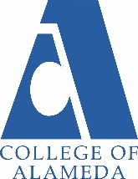
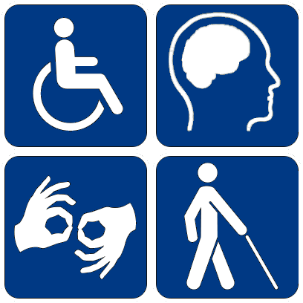
Speciality Programs at College of Alameda
In addition to our general SAS program for students enrolled
at College of Alameda we offer the following specialty programs:

Cognitive Rehabilitation Program – Improving Cognitive Skills classes
Who: Students with Acquired Brain Injuries and Learning Disabilities
Focus: Improving attention skills, memory strategies, recognition of verbal and nonverbal patterns, basics of brain function, organization & critical evaluation of information, strategies in problem solving.
To enroll, apply as a student at College of Alameda and meet with a SAS counselor.
Instructor: Phyllis Tappe email: ptappe@peralta.edu
https://alameda.peralta.edu/student-service/dsps/acquired-brain-injury-cognitive-rehabilitation-program/

College to Career
Who: Individuals with intellectual disability or autism who are eligible for Department of Rehabilitation services and who have graduated with a HS diploma, or have exited HS transition programs.
Focus: Preparing students with intellectual disabilities and autism for competitive independent employment. The program includes academic counseling, C2C classes, on-campus educational coaching, internships related to students’ employment goals, and employment placement with follow-up, as needed.
Applying: Applications for the C2C program are typically available in November, due dates may vary please check with the C2C Coordinator. Admissions interviews and decisions will be completed in the spring and the program classes will begin each fall semester. C2C admits up to 20 students each year.
C2C Office location: College of Alameda Cougar Village (CV-136)
C2C Coordinator: Jennifer Sanoh email: jsanoh@peralta.edu phone: 510-748-2359
https://alameda.peralta.edu/college-to-career/

Learning Skills Program
Who: Students with Learning Disabilities, including those students who are seeking assessment to determine eligibility.
Focus: The Learning Skills Program provides instruction, counseling, and support services to help students with learning disabilities meet their academic and career goals. Courses include: Diagnostic Assessment, Writing Strategies and Math Strategies.
To enroll, apply as a student at College of Alameda and meet with a SAS counselor.
Instructor: Lynn Rex email: lrex@peralta.edu
https://alameda.peralta.edu/student-service/dsps/learning-skills-program-dsps/

WorkAbility III
Who: Participants in the program must be State Department of Rehabilitation clients and be referred by their DOR counselor to be eligible for services. All participants must also be eligible to enroll as COA students.
Focus: The objective of the program is to form a partnership with individual clients to meet their employment goals. WAIII offers job search workshops, job clubs, individualized job placement assistance, and follow up support on the job.
WAIII Office location: College of Alameda Cougar Village (CV-136) Phone: 510/748-2152
https://alameda.peralta.edu/student-service/dsps/workability-iii/

